Task 5 - Configuration Management:

1. Understand the importance of Iaac.

2. Compare different Iaac available (Ansible,Saltstack,Puppet, Chef etc)

2. Go through Ansible and Terraform basics.

3. Create scripts for different types of automation. (Just try random)

-----------------------------------------------------------------------------------------------------------

1. Understand the importance of Iaac.

Iaac means, I have given a cmd how to create a vpc and ec2 and using this u can deploy 200+ services in aws and that command can be written in ymal shell etc and this becomes code, deploying infrastructure using code or cmd is called as iaac. These are not software code it’s a simplified version of executing the scripts.

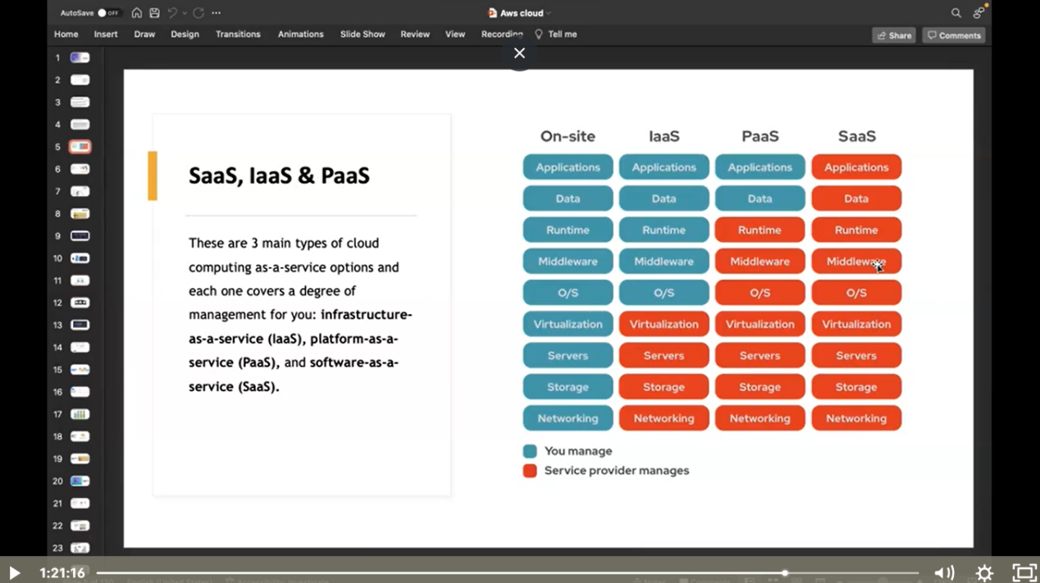

Consider an example a company has given u a project a bank project to develop and the company says u have to look after all the performance of the application like when it goes down infrastructure etc because he has to focus in business and u should be responsible for performance issue.

Now to on board(creating app) a customer we have to create a infrastructure for a project that involves LB VPC EC2 IG IAM ILB RT etc. And now I have assigned different tasks to 2-3 people and that u have to perform this task manually. And for this project company will give a SOP and involves a step to perform the operation. And u have to follow those steps to install ec2, create vpc etc here there can be more than 7-8 steps u have to perform to install vpc etc and this will take lot of time inorder to overcome this we have to use automation because the work that would take 3-5 days will complete with 30 minutes this is the use of automation.

1. Compare different Iaac available (Ansible,Saltstack,Puppet, Chef etc)

-------------------------------------------------------------------------------------------------

https://www.justaftermidnight247.com/insights/chef-vs-puppet-vs-ansible-vs-saltstack-configuration-management-tools-compared/#:~:text=Ansible%20can%20run%20push%20or,workloads%20it%20can%20effectively%20run.

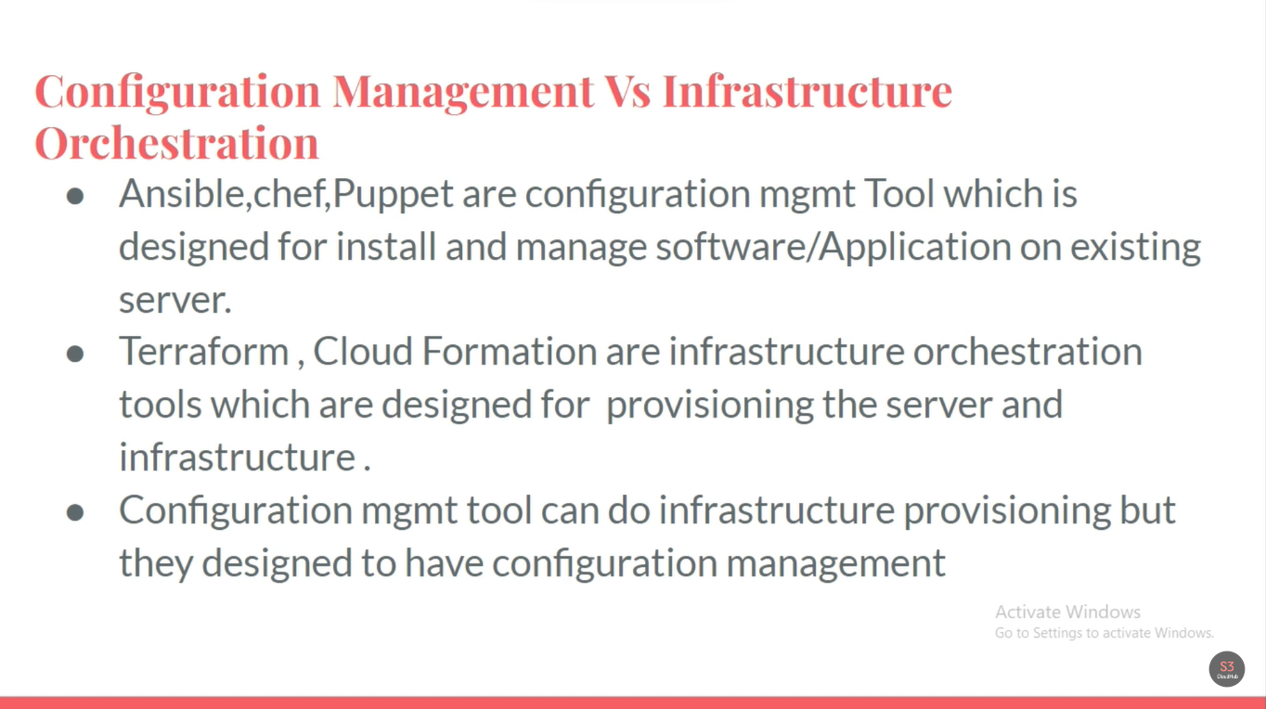

1. Go through Ansible and Terraform basics

----------------------------------------------------------

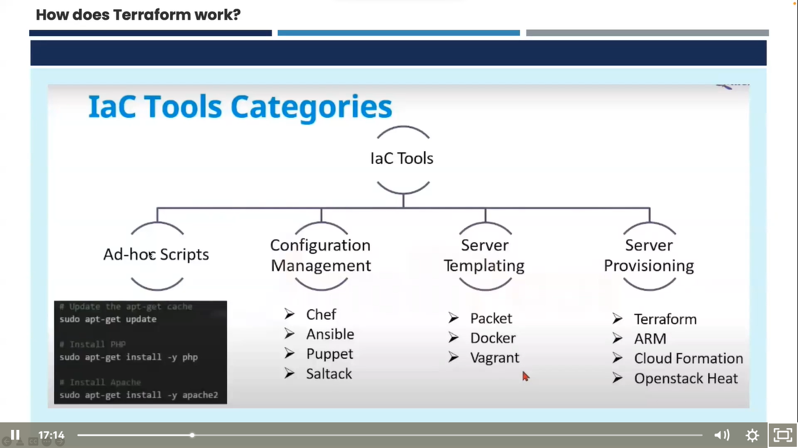

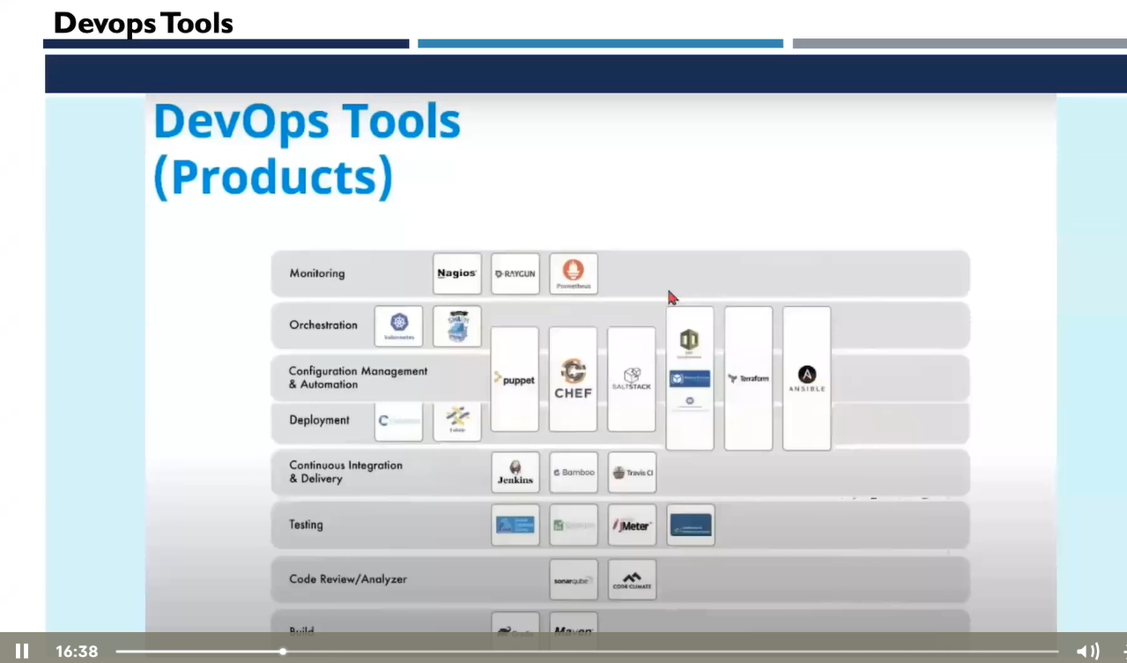

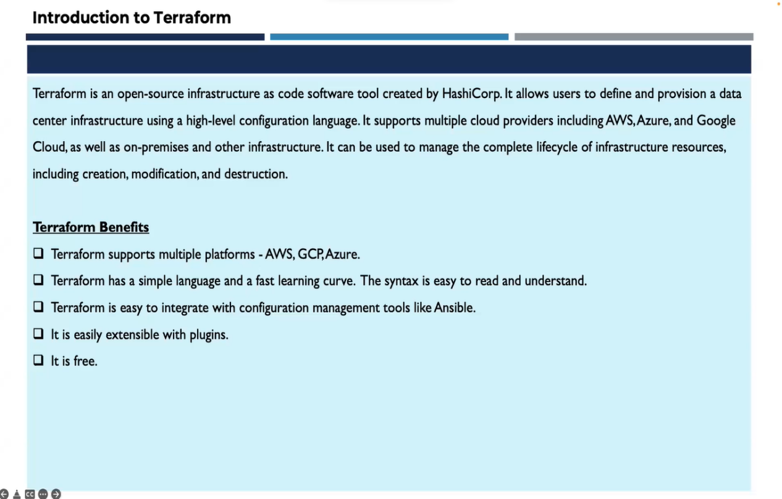

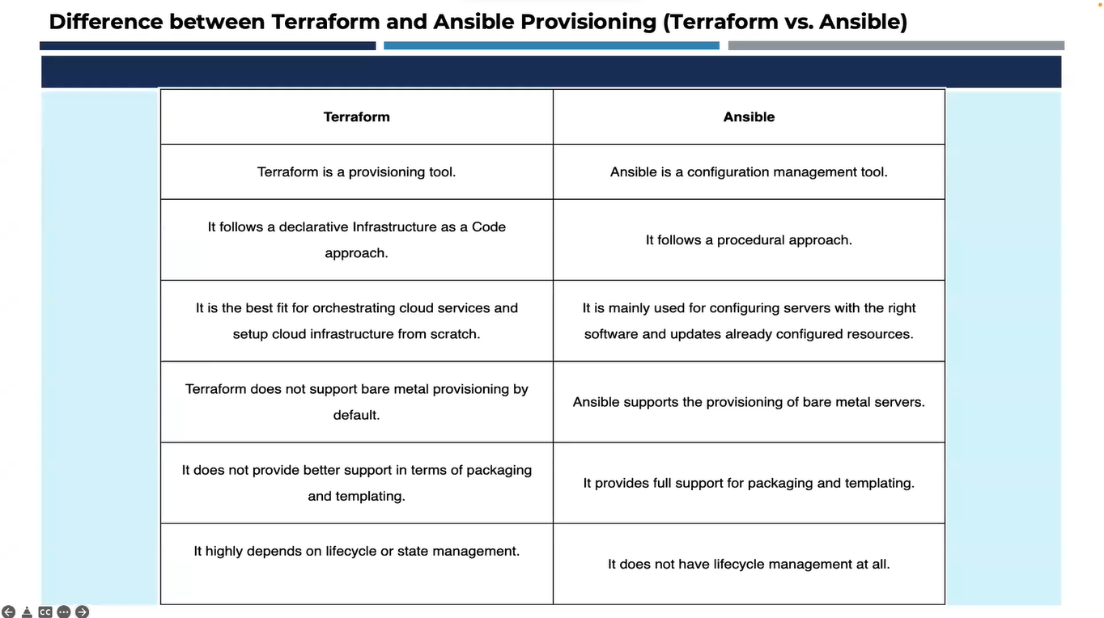

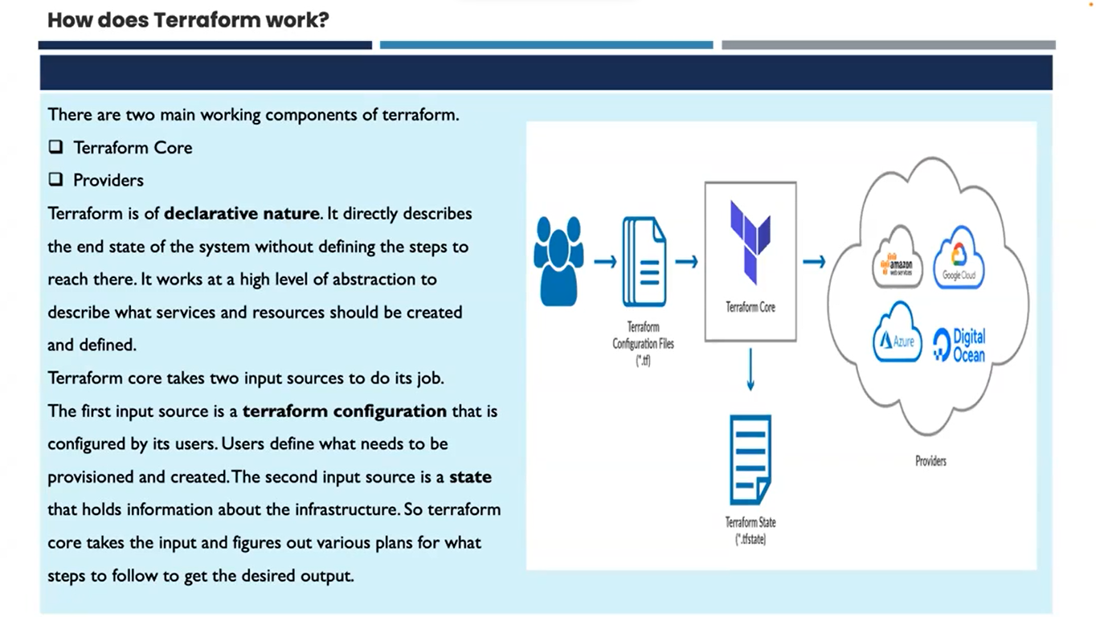

Terraform lifecycle

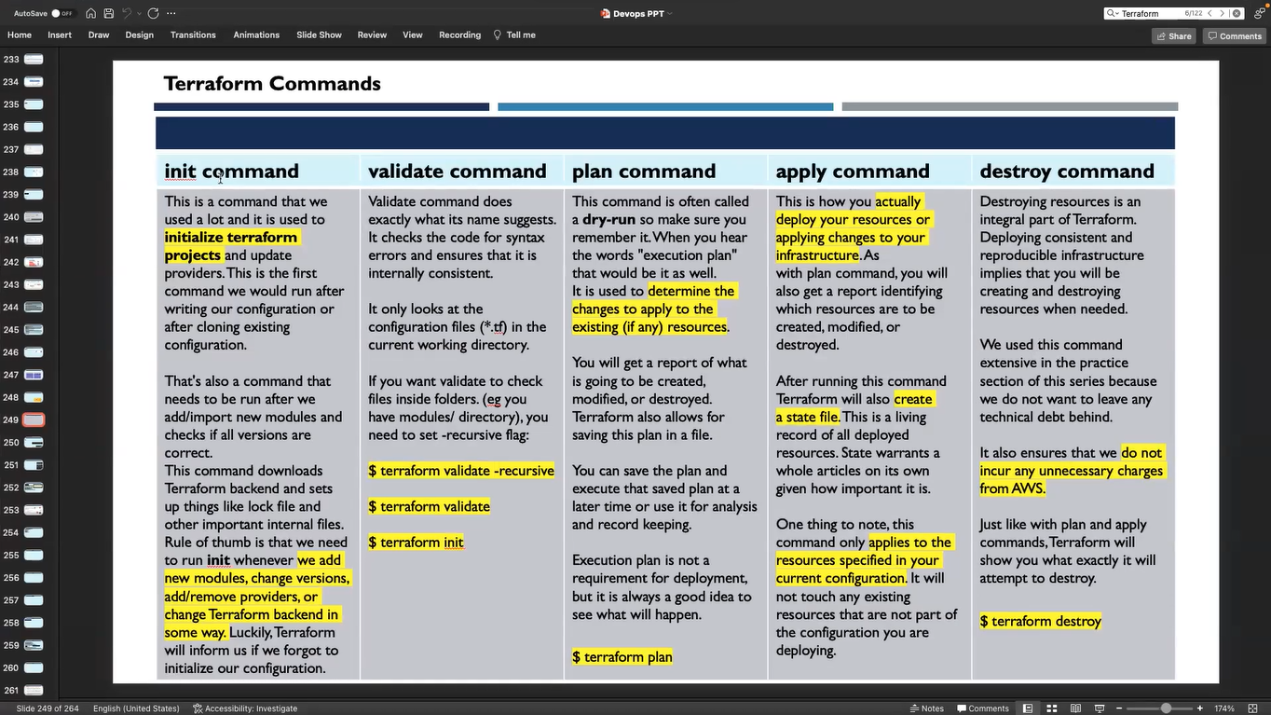

Ansible

